EGERTON UNIVERSITY LIBRARY ORGANIZATIONAL CHART
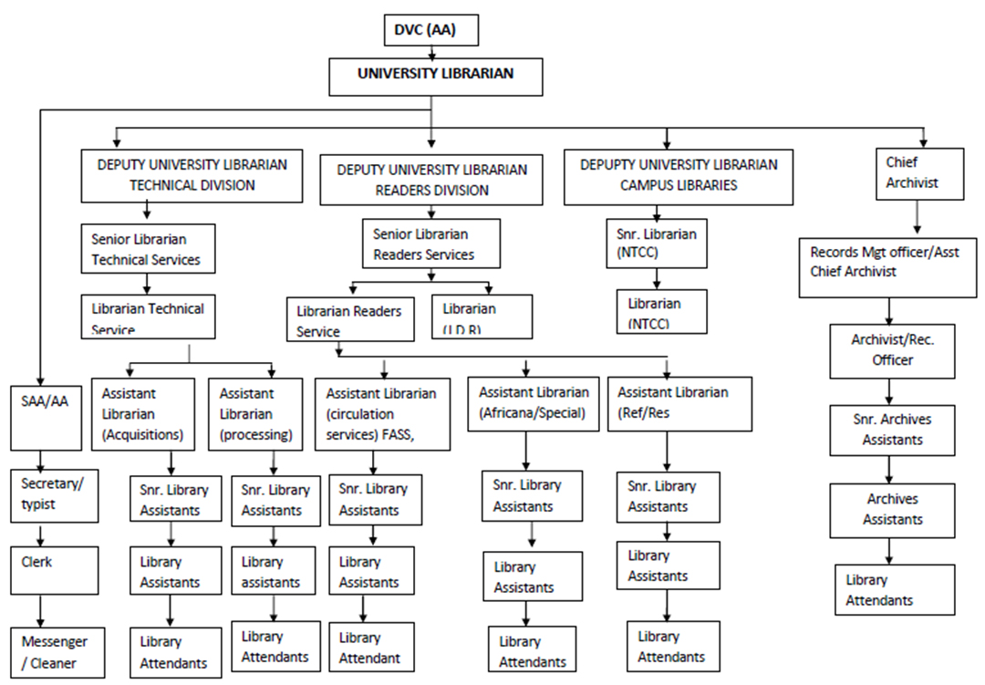
RMAC – Records Management and Archives Centre
J.D.R. – J.D. Rockefeller Library
FASS – Faculty of Arts and Social sciences Library
NTCC – Nakuru Town Campus College Library
FHS – Faculty of Health Sciences Library
FOL – Faculty of Law Library
FEDCOS – Faculty of Education and Community Studies
SAA – Senior Administrative Assistant

//////O
Convincing a librarian about the introduction of user feedback, student projects and exhibitions, and a rating system on the university website involves presenting a well-reasoned proposal. Here’s a structured approach to make your case:

### 1. **Understand Their Perspective**
- **Research the Library’s Goals**: Familiarize yourself with the library’s mission, values, and current initiatives. This will help you frame your proposal in a way that aligns with their objectives.

### 2. **Prepare a Clear Proposal**
- **Outline the Features**: Clearly describe each proposed feature (user feedback, student projects and exhibitions, rating system) and how they function.
- **Benefits to the Library**:
- **User Feedback**: Enhances service quality, identifies user needs, and fosters community engagement.
- **Student Projects and Exhibitions**: Showcases student work, promotes academic excellence, and encourages collaboration.
- **Rating System**: Provides insights into resource effectiveness and helps prioritize improvements based on user preferences.

### 3. **Present Evidence and Examples**
- **Case Studies**: Share examples from other university libraries or institutions that have successfully implemented similar features. Highlight positive outcomes like increased user satisfaction or engagement.
- **User Testimonials**: If possible, gather feedback from students or faculty expressing a desire for these features.

### 4. **Address Potential Concerns**
- **Privacy and Moderation**: Discuss how user feedback will be moderated to ensure constructive comments while protecting user privacy.
- **Resource Allocation**: Acknowledge potential resource needs (staff time, technical support) and suggest phased implementation or pilot programs to minimize strain.
- **Technical Feasibility**: Collaborate with IT or web development teams to explore the technical aspects, ensuring feasibility without extensive investment.

### 5. **Emphasize Collaboration**
- **Invite Librarian Input**: Encourage the librarian to provide input on the proposal. This fosters a sense of ownership and collaboration, making them more likely to support it.
- **Pilot Program**: Propose starting with a pilot program to test the features on a smaller scale, allowing for adjustments based on initial feedback.

### 6. **Show Alignment with User Needs**
- **Survey Data**: If available, present data from surveys or focus groups indicating user interest in these features.
- **Enhancing User Experience**: Emphasize how these features will enhance the overall user experience, making the library a more integral part of student life.

### 7. **Follow Up with a Summary**
- After your presentation, provide a concise summary of your proposal, including the main points, benefits, and next steps. This ensures clarity and gives the librarian something to refer back to.

### 8. **Be Open to Feedback**
- Be receptive to any concerns or suggestions the librarian may have, and be willing to adjust your proposal accordingly.

### Conclusion
By presenting a well-structured proposal that highlights the benefits to both users and the library, and by addressing potential concerns proactively, you’ll be in a strong position to convince the librarian of the value of these initiatives. If you need further assistance or specific details oBy presenting a well-structured proposal that highlights the benefits to both users and the library, and by addressing potential concerns proactively, you’ll be in a strong position to convince the librarian of the value of these initiatives. If you need further assistance or specific details on any point, feel free to asK

